KMC Hackathon 1.0 Project Report:
Project Title: Smart Flash Card Learning App
Team Name: G.O.A.T.S.
Team Members: Sanjil Basnet,Prabav Humagain,Siddhant Karki
Mentor: Aman Sir

1. Abstract
Students often struggle to memorize key concepts efficiently. Traditional study methods can be repetitive and boring. Our project introduces a Smart Flash Card Learning App that allows students to create, share, and practice flash cards digitally. The app uses spaced repetition techniques to improve memory retention and makes learning interactive, fun, and accessible anytime.

2. Problem Statement
Memorization of facts, vocabulary, and formulas is essential in school learning. However, students rely on paper flash cards or rote learning, which is time-consuming, difficult to organize, and lacks personalization. There is a need for a digital solution that makes memorization smarter and more engaging.

3. Existing System
Currently, students use notebooks or paper flash cards to study. These methods:
- Are hard to carry and organize.
- Do not adapt to individual learning speed.
- Lack interactive features like quizzes or progress tracking.

4. Proposed Solution
We developed a Flash Card App where students can:
- Create custom flash cards with text, images, or audio.
- Practice using spaced repetition algorithms.
- Track progress with performance analytics.
- Share flash card sets with classmates for collaborative learning.

5. Objectives
- Make memorization more engaging and efficient.
- Provide a digital platform for flash card creation and practice.
- Enable collaborative learning through sharing.
- Improve retention using smart repetition techniques.

6. Technology Used
- Frontend: HTML, CSS, JavaScript / React Native
- Backend: Python (Flask) / Node.js
- Database: Firebase / MySQL
- Algorithms: Spaced Repetition (Leitner System)
- Devices: Smartphone / Laptop

7. System Wireframe
- Student Dashboard: Create and view flash cards.
- Practice Mode: Quiz-style interface with progress tracking.
- Analytics Page: Shows accuracy, weak areas, and study streaks.

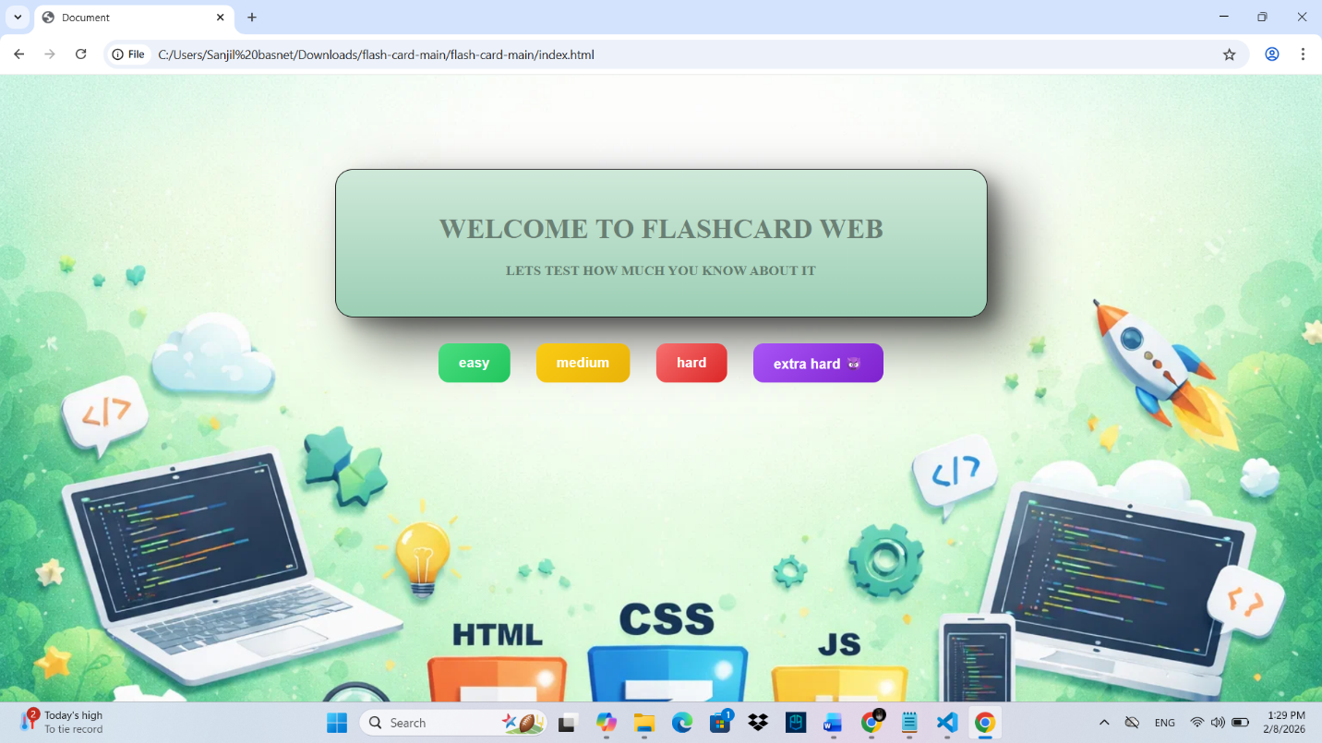
FIG-1:HOME PAGE OF THE FLASH CARD
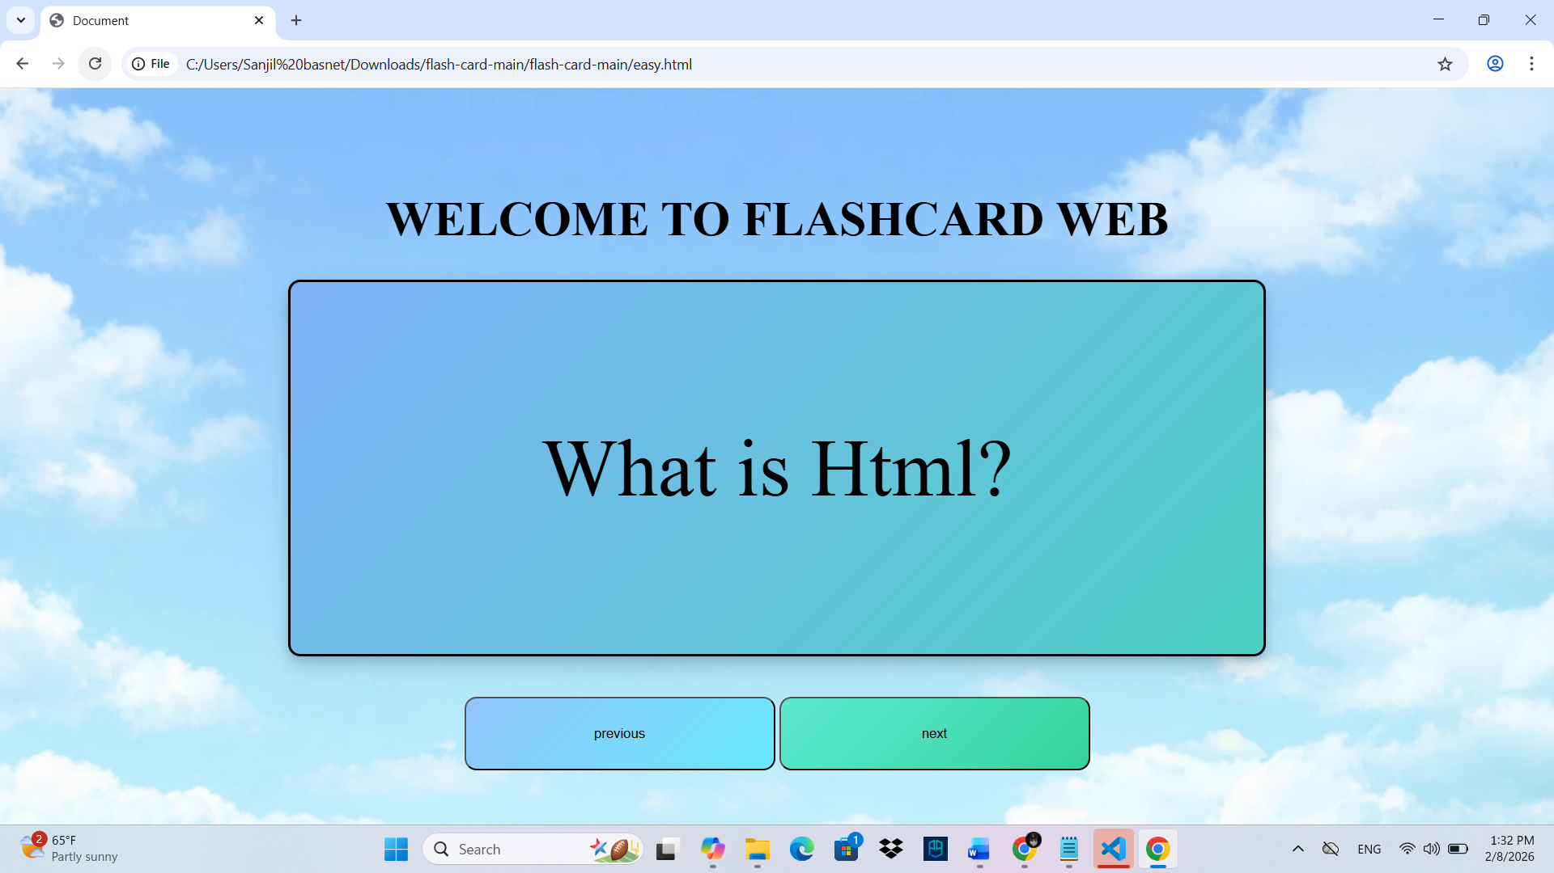
FIG-2:EASY PAGE FO THE FLASH CARD

8. Results
Testing showed that students using the app could recall vocabulary and formulas faster compared to traditional methods. The app reduced study time while improving accuracy and retention.

9. Advantages
- Portable and paperless learning.
- Personalized study experience.
- Encourages collaboration among students.
- Fun and interactive compared to rote memorization.

10. Limitations
- Requires internet access for syncing.
- Initial setup and learning curve for new users.
- Limited offline functionality in current version.

11. Future Improvements
- AI-powered flash card suggestions based on syllabus.
- Voice recognition for pronunciation practice.
- Gamification features (leaderboards, rewards).
- Full offline mode with sync-on-connect.

12. Conclusion
The Smart Flash Card Learning App transforms traditional memorization into an interactive digital experience. By combining technology with proven learning techniques, it helps students study smarter, retain knowledge longer, and collaborate effectively. This project demonstrates how simple digital tools can revolutionize education.

